Name: Sandesh Varma                                                                     Date: 15/09/2025

Roll No: CH.EN.U4CSE22078

Experiment No: 8

___________________________________________________________________

Aim: To write a program that implements the target code generation.

# **Algorithm:**

# Read input string

# Consider each input string and convert it to machine code instructions using switch case

# Load the input variables into new variables as operands and display them using “load”

# With the help of arithmetic operation, we will display arithmetic operations like add, sub, div, mul for the respective operations in switch case

# Generate 3 address code for each input variable.

# If ‘=‘ is seen as arithmetic operation, then store the result in a variable and display it with “store”.

# Repeat this for each line in the input string.

# Display the output which gives a transformed input string of assembly language code.

Code:

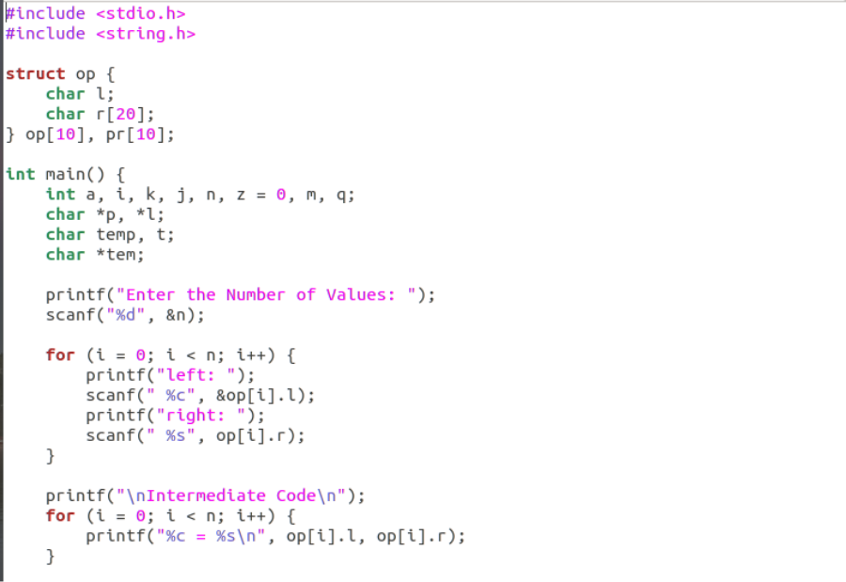

Sandesh Varma

CH.EN.U4CSE22078

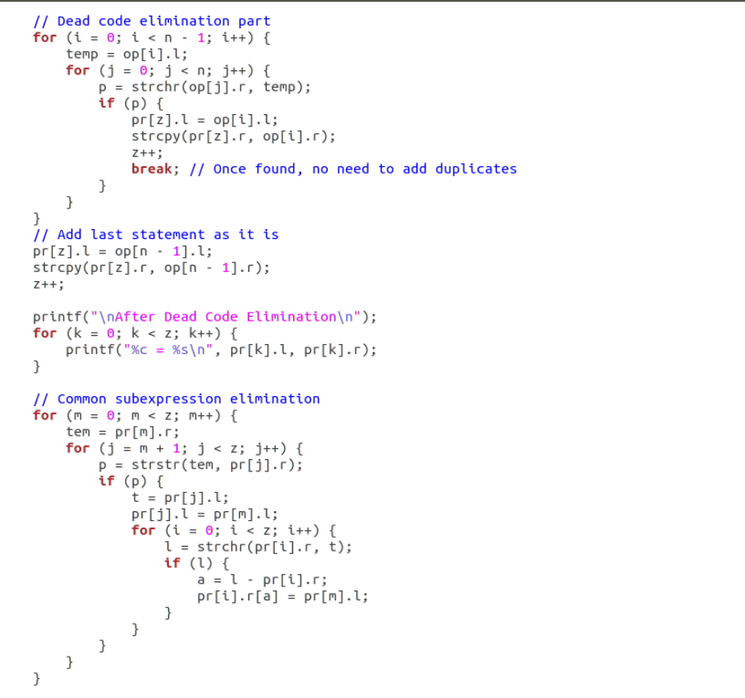

Output:

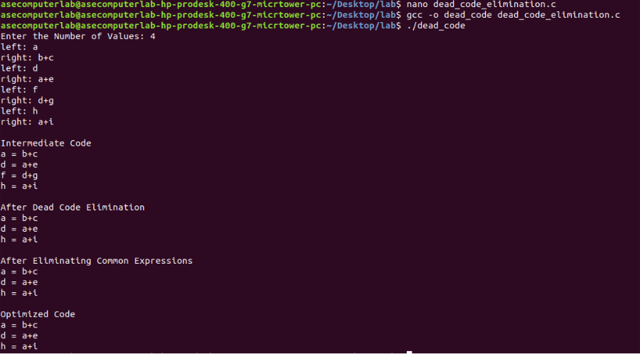

Results: The program that implements the target code generation has been executed successfully.